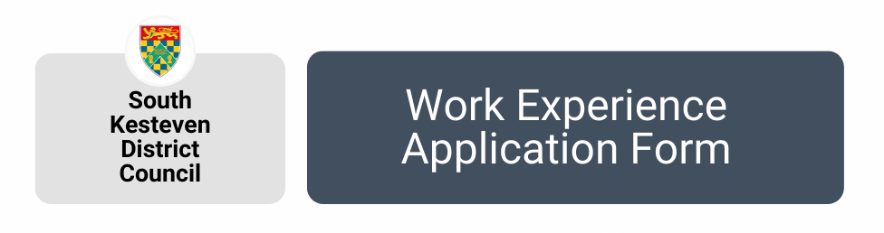

PERSONAL DETAILS

Name:
Email:
Telephone:
Age:
Do you have any medical conditions we need to be aware of?
Yes No If yes, please give details:

Do you have a disability?
Yes No If yes, please give details:

YOUR PLACEMENT

Please tick which area(s) you would like to carry out your work experience:
Communications Housing
Customer Service Housing Technical Services
Democratic Services Human Resources
Economic Development IT
Electoral Services Planning
Environmental Health/ Public Protection Repairs
Finance Waste & Recycling

Why did you choose SKDC for your work placement?

When would you like your work placement to start, and for how long?

PARENTAL CONSENT

If you are under the age of 18, we require parental consent.
Please ask your parent/ guardian/ carer to sign below and provide their name and relationship to you:

EMERGENCY CONTACT DETAILS

Name:
Address:
Telephone:
Email:
Their relationship to you:
SCHOOL / COLLEGE / UNIVERSITY

Name of your school / college / university:
Contact name:
Phone:
Email:
NEXT STEPS

Once you have completed this form please return via email: hr@southkesteven.gov.uk

Please note - we cannot always guarantee a placement and we require at least four weeks’ notice for all applications

